Section A: Getting Started
1 | Open a web browser and type crowd.library.wales/en/s/kyffin in the address bar, and then press Enter.  The National Library of Wales would encourage you to use a recent version of a modern web browser such as Firefox or Chrome when contributing to this platform.
2 | If you are visiting this site for the first time you will need to register by clicking the Sign Up link on the top right hand of the screen and following the instructions on the next screen to create an account.  If you are returning to the site, then you can start working immediately by clicking on Login and entering your details. | 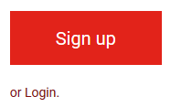
3 | Now that you are ready to start contributing to the collection click on Get Started and then choose one of the collections, and click on View whole collection | 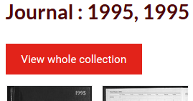
4 | On the next page you can choose which item you would like to annotate, or if you are returning to the site, you can continue annotating an item that you started working on previously.  The colour below the item indicates its status.  - The small red square and grey bar at the bottom indicates that no one has worked with this image.  - The orange bar across half of the bottom indicates that work has started on annotating this image, but that it has not been completed.  - If the bar across the bottom of an image is green, then the annotation on this image is complete.

If you want to edit an item that has no annotations (red square) move on to Section B.
If you are editing an item that has already been partially annotated (orange bar) move on to Section C.
Section B: Annotating an item for the first time
1 | 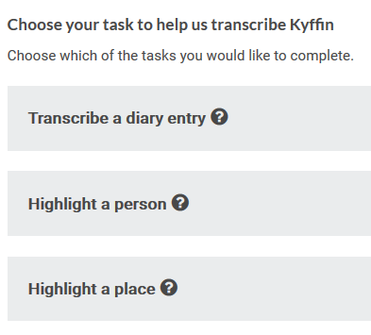  Click on the image you want to transcribe.  Before you can begin working with this document you will need to choose what type of information you wish to contribute. You can hover on the question marks for guidance. | You can use the ‘+’ and ‘-‘ signs or the wheel on your mouse to scroll in and out.  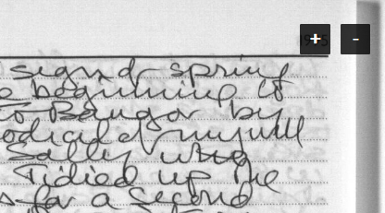
2 | Transcribe a Diary Entry:  Please transcribe all the text relating to one date in the diary.  To guess a word, please use square brackets, e.g. [Nant Peris].  If a word/words are illegible, please state this, e.g. [one illegible word], or [three illegible words].  Please overwrite the calendar by typing dates in this format: DD/MM/YYY.  Once you finish transcribing you should click on Next > and then on the red Save button below the text.  If there is more than one date entry on the page, please click on ‘continue annotating this image’ and repeat the above steps. | 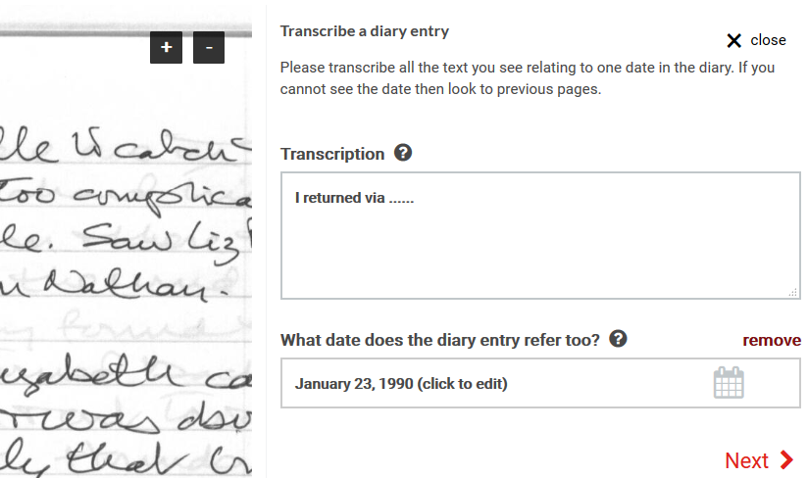
3 | 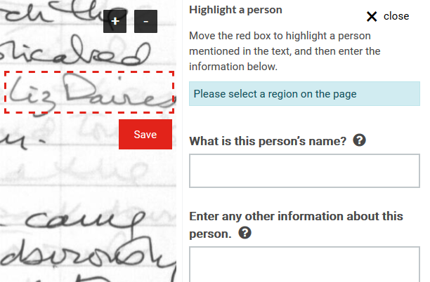 | Highlight a person:  Drag the red box across the image and adjust its size until it fits around the name of the person you want to describe. Click ‘save’ under the red box.  Record information about this person in the text boxes.  Once you are finished you should click on Next > and then on the red Save button below the text.  You can repeat this for each person that you want to record.
4 | Highlight a place:  Move the red box to highlight a place mentioned in the text, and then enter the information in the text box. The system will find the place in Google maps.  Once you are finished click on Next > and then on the red Save button below the text.  You can repeat this for each place name that you want to record. | 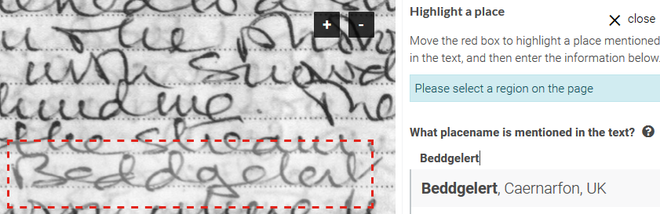
5 | Bookmark / Complete:  Once saved you can also Bookmark the page by clicking the button on the bottom right of the screen. All your bookmark selections can be viewed by clicking on your name in the top right of the page – this is the best way of finding documents that you have previously worked on.  If you finish annotating all the text, persons and places please click the button on the bottom right of the screen to mark that page as complete. This will change its status to green (Mark as complete). | 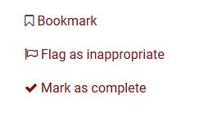
6 | Viewing annotations:  Annotations are displayed as thumbnails directly below the image. | 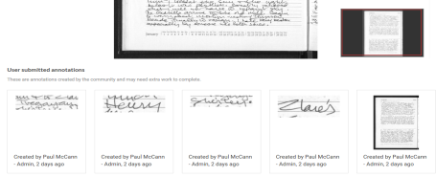
7 | Choose the next image:  Scroll to the carousel at the bottom of the screen and choose the next image you wish to describe. | 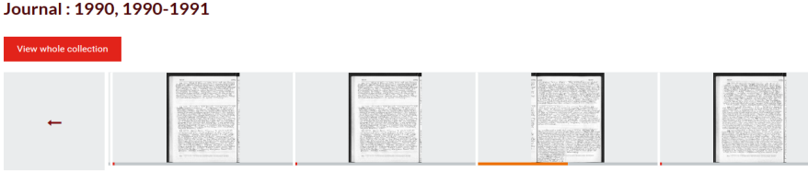

Section c: editing an item that has already been partially annotated
1 | Images that have an orange bar across the bottom have been partially annotated. You may wish to work on this type of image by:  - Editing your own annotations and returning to annotate a page that you have already begun working on.  - Editing annotations that others have started but have not completed.  First you will need to click on the image to take you to the annotating page. | 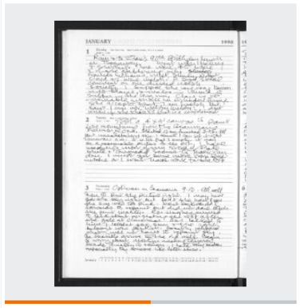
2 | Below the image you will see thumbnails representing annotations that already exist. If you wish to edit one of these, click on the annotation and a new dialogue will appear with an < Edit button.  Click on this button to edit the annotation, when you have finished editing click Next > and then the red Save button.  If you finish annotating the whole item you can use the button on the bottom right of the screen to mark that page as complete, as shown in step 6 of Section B. | 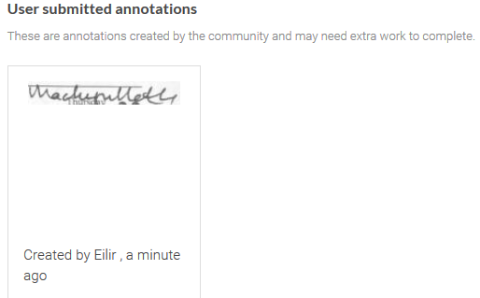
3 | If you are unable to read the document due to the various annotation boxes covering the text, click the toggle button on the top left of the text page - this will hide these boxes from view.

